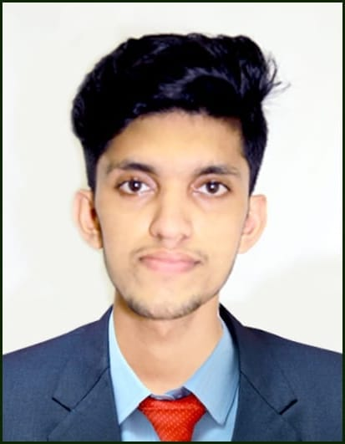**SAJITH NV**

|  |  |
| --- | --- |
| **Phone** | **: 9072495440** |
| **Email** | **:** [**sajisajithnv@gmail.com**](mailto:sajisajithnv@gmail.com) |
| **Profile** | **:** [**https://sajithnv.github.io/SAJITH_NV**](https://sajithnv.github.io/SAJITH_NV) |
| **GitHub** | **:** [**https://github.com/sajithnv**](https://github.com/sajithnv) |
| **LinkedIn** | **:** [**https://www.linkedin.com/in/sajith-nv-44a6a31bb**](https://www.linkedin.com/in/sajith-nv-44a6a31bb) |

**PROFILE SUMMARY**

I am a passionate Computer Application postgraduate looking to enhance my professional skills, capabilities and knowledge in an organization that recognizes the value of hard work and trusts me with responsibilities and challenges.

ACHIEVEMENTS

* **Certifications :**
* Completed a certified course in Python Django (6-7 months from LIVEWIRE).
* Completed Internship in ‘Internet Of Things’ ( IOT ).
* **Accomplishment :**
* Secured **First Place** in **Project Exhibition** of ‘SAMSHODAN-23’ Intra college fest.
* Won **First Prize** in **Coding and Debugging** of ‘FESTIVISTA-23’ Intra college fest.
* Participated in **Final** round of National Level IT Fest- JOSHIANA 11.0
* Participated in the National Level IT Fest- SEMAPHORE-23

**EDUCATION**

* **Master Of Computer Applications** (**MCA**) from Shree Devi Institute Of Technology (SDIT) – Present

**( 2021-2023 )**

* **Diploma in Python Django** from LiveWire – **( 2020-2021)**
* **Bachelor Of Computer Applications** (**BCA**) from Shree Devi College (SDC) with **63%** result -

**( 2017-2020 )**

* **Higher Secondary** from Vocational Higher Secondary School with **60%** result - **( 2015-2017 )**
* **SSLC** from GEMS High School with **75%** result - **( 2014-2015 )**

**PROJECTS**

* **FIND MY TRADIE (Web_Project- 2023)**

FindMyTradie is a web-based application that allows users to find qualified employees in their area. Users can search for employees by trade name, location and other criteria. It provides users with employee reviews and ratings so they can make an informed decision about who to choose.

* **SMART PARKING SYSTEM (IOT_Project- 2023)**

Smart Parking System – Used to locate parking spaces and provide drivers with the up-to-the-minute information about available parking lots.

* **GAME ZONE (Mini_Project- 2023)**

Mini Games App- It contains a collection of fun and addictive mini games. Developed using Python and its package tkinter.

* **Paying Guest Management System (MCA- WEB Mini_Project- 2022)**

This system will contain database that enables to store the data and retrieving each transactions of the customers. This would generate a faster improvisation of work with less time and effort.

* **E-commerce Textile Shop (Diploma in Django - 2021)**

It’s a web application like Amazon and Flipkart ,used to manage the purchasing details ,transactions etc.

* **Blood Bank Management System (Diploma in Python -2021)**

A blood bank management system (BBMS) is a software application that helps blood banks to manage their inventory of blood products, track blood donations, and manage donor information. BBMSs can also be used to automate tasks such as blood typing, cross-matching, and issuing blood products.

* **Fancy Shop Franchise (BCA - 2020)**

“Fancy shop franchise” is a web application to manage the information of purchasing fancy products of different categories. These categories also include the company or brand details. Franchises are maintaining shops in different location based on customer’s address they will receive orders from them. Customers can do online payment for ordered products.

**Key Skills**

* **Technical Skils**
* Python(Django), JAVA, C, C++
* HTML, CSS, JS, Bootstrap
* MySQL, SQLite
* GitHub (VCS)
* **Non-technical Skills**
* Leadership Skills
* Creative Thinking
* Time Management
* Communication Skills

**PERSONAL INFORMATION**

* Nationality : Indian
* Address : 205-A Nellikkat, Balla P.O, Kanhangad, Kasaragod, Kerala 671531.
* Marital Status : Single
* DOB : 25-Dec-1999
* Gender : Male
* Languages : English, Malayalam, Tamil

**DECLARATION**

I hereby declare that the information included above is true to the best of my knowledge.

Date : / / 2023

Place : Kanhangad SAJITH NV